DATA ANALYTICS PROJECT REPORT

Customer Shopping Behavior Analysis

Tools Used: MySQL · Python · Power BI

Prepared by: Noor Mohammad

10th June 2026

1. Project Overview
This project analyzes customer shopping behavior using MySQL, Python (Pandas), and Power BI. It details the comprehensive analysis of customer shopping behavior utilizing a dataset of 3,900 unique transactional records. The objective was to identify revenue-driving customer demographics, seasonal purchasing trends, discount effectiveness, customer loyalty patterns, and the relationship between shipping preferences and order value. Insights were translated into business recommendations to support data-driven decision making.
2. Project Objectives
• Identify which customer demographics generate the most revenue.
• Uncover seasonal trends in purchase behavior by product category.
• Measure the effect of discounts on purchase amounts.
• Segment customers based on purchasing patterns and average spend.
• Understand the relationship between shipping preference and order value.
3. Dataset Summary
The analytical foundation consists of a high-fidelity dataset structured as follows:
- Dimensions: 3,900 observations across 18 feature dimensions.
Key Feature Categories
Customer Demographics | Purchase Details | Shopping Behavior
Age | Item Purchased | Discount Applied
Gender | Category | Promo Code Used
Location | Purchase Amount | Previous Purchases
Subscription Status | Season | Frequency of Purchases
— | Size | Review Rating
— | Color | Shipping Type

4. Exploratory Data Analysis using Python
The initial workflow utilized the pandas library for structural assessment and statistical profiling.
- Data Loading: Imported the dataset using pandas.
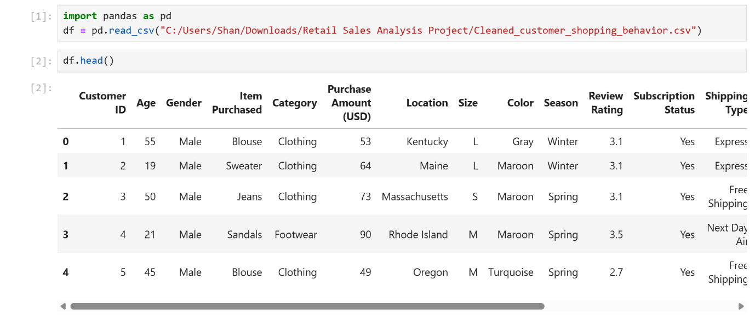
- Initial Exploration: Used df.info() to check structure and .describe() for summary statistics.
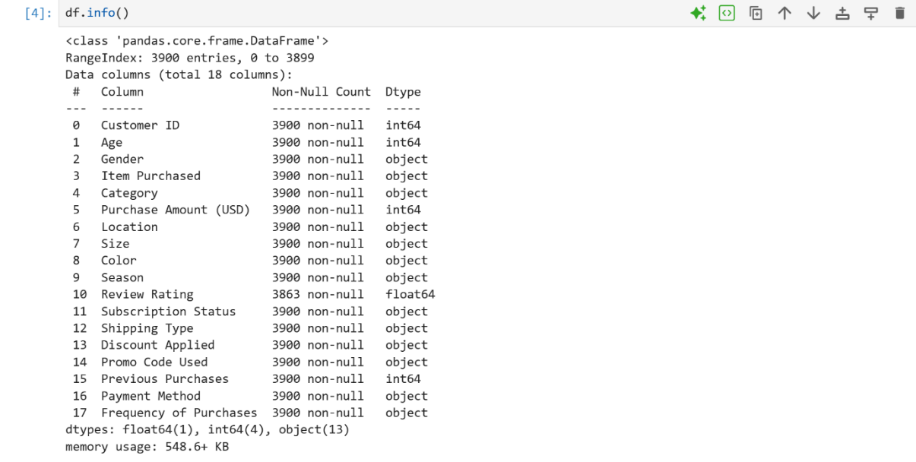
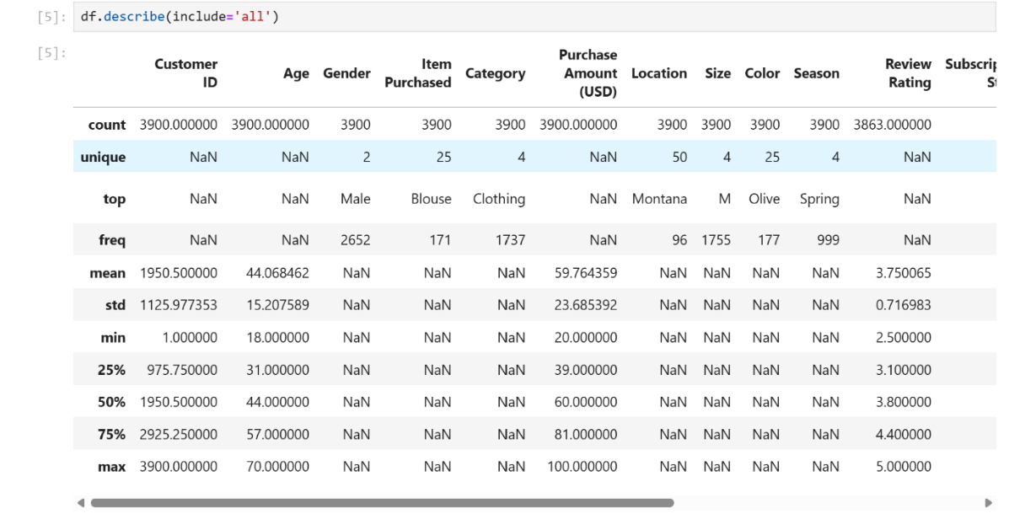

- Missing Data Handling: Checked for null values and imputed missing values in the Review Rating column using the median rating of each product category.
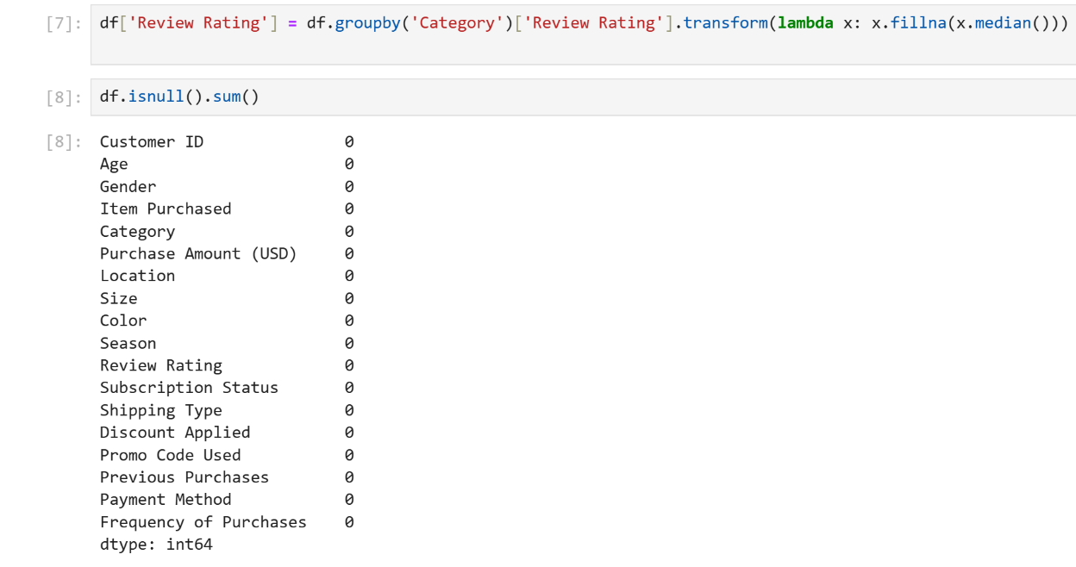
- Column Standardization: Renamed columns to snake_case for better readability and documentation.
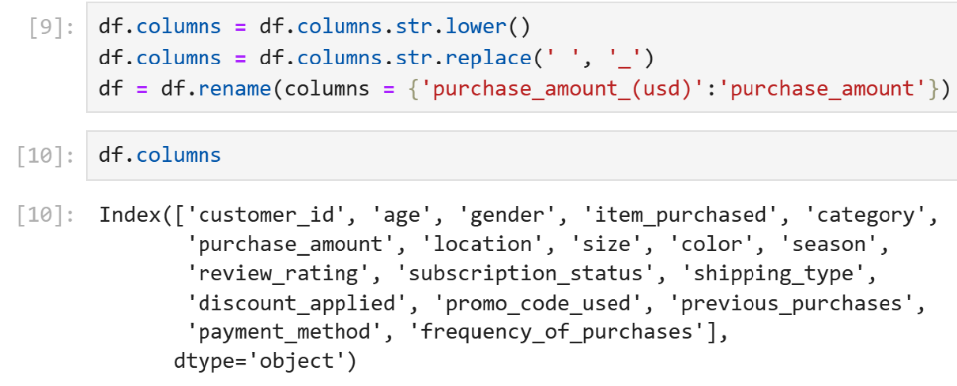

- Feature Engineering:
  - Created age_group column by binning customer ages.
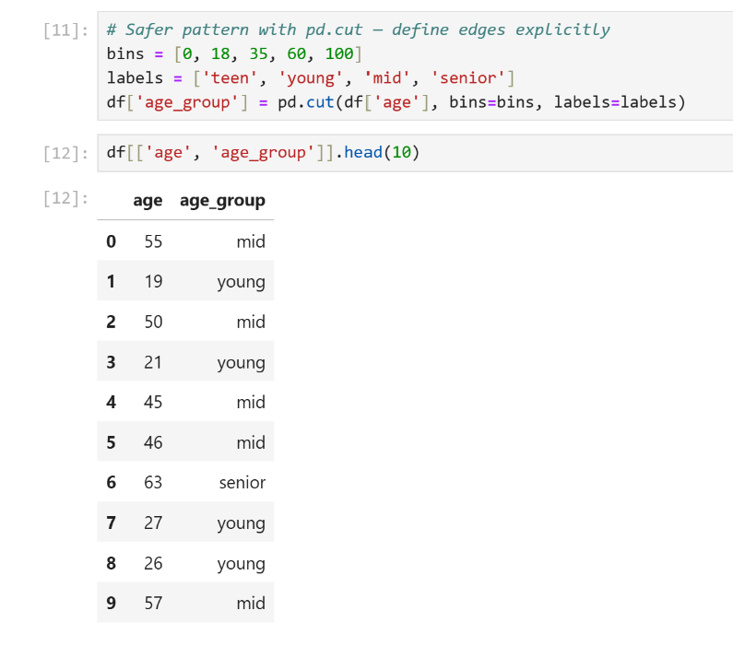

  - Created purchase_frequency_days column from purchase data.
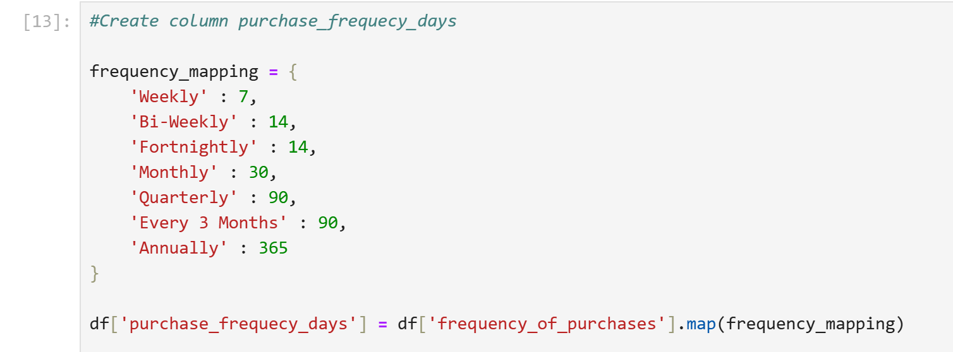
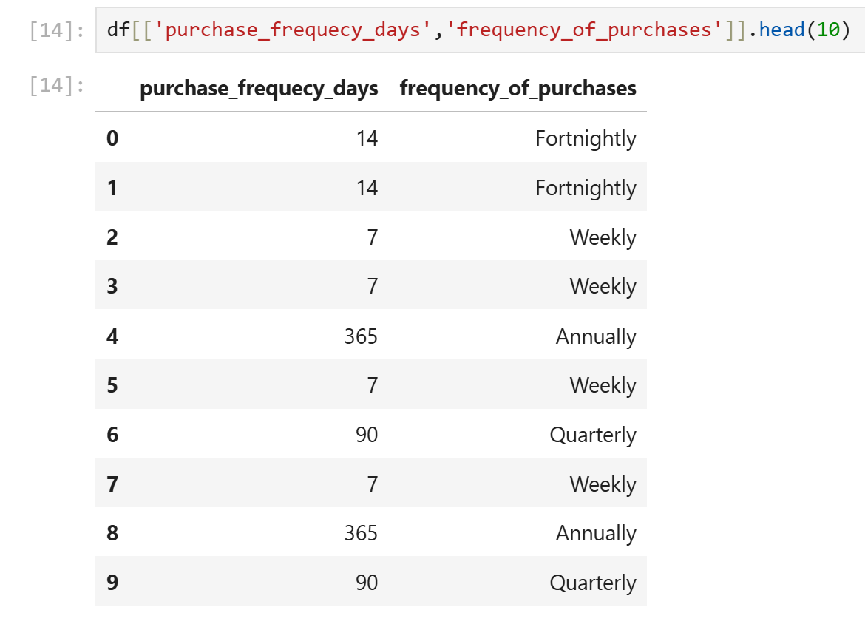

- Data Consistency Check: Verified if discount_applied and promo_code_used were redundant; dropped promo_code_used.
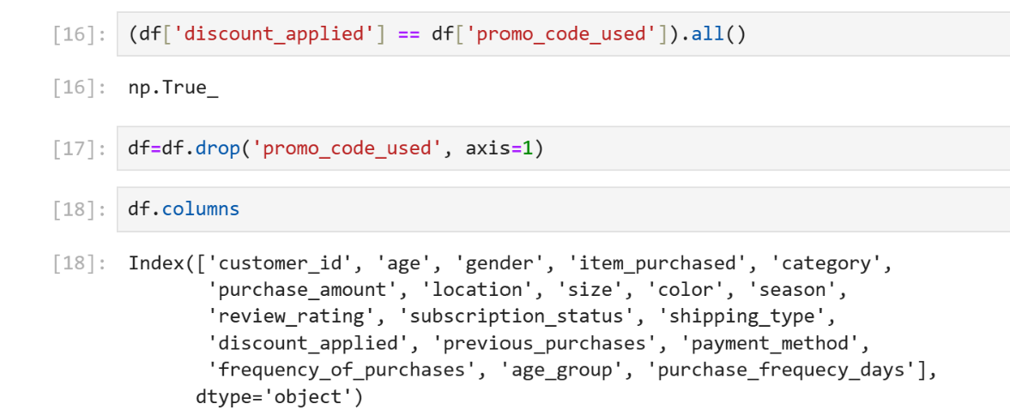

- Database Integration: Connected Python script to PostgreSQL and loaded the cleaned DataFrame into the database for SQL analysis.
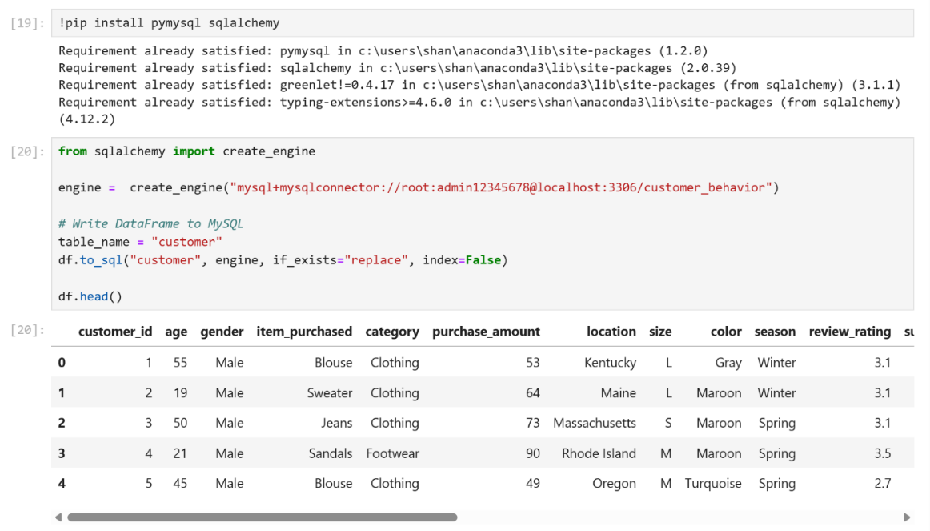

4.1 Summary Statistics
• Age Profile: Customer age ranges from 18 to 70 years with an average age of 44.07 years.
• Financial Metrics: Purchase amounts range between $20 and $100. Average purchase amount is $59.76 with a standard deviation of $23.69.
• Gender Distribution: Male customers represent the largest segment (2,652 customers).
• Category Distribution: Clothing is the most purchased product category (1,737 purchases).

5. Data Analysis using SQL
We performed structured analysis in PostgreSQL to answer key business questions:
- Revenue by Gender – Compared total revenue generated by male vs. female customers.
SELECT gender, sum(purchase_amount) as total_revenue
FROM customer
GROUP BY gender;
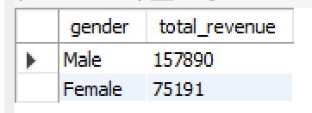

- Revenue by Age Group – Identified which age segments contribute the most to revenue.
SELECT age_group, sum(purchase_amount) AS revenue
FROM customer
GROUP BY age_group
ORDER BY revenue DESC;
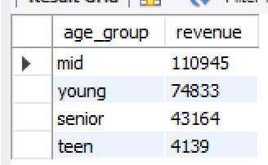

- Top Product Categories – Ranked categories by total avg review ratings.
SELECT category,
ROUND(AVG(review_rating),1) AS rating,
RANK() OVER (ORDER BY AVG(review_rating) DESC) AS rnk
FROM customer
GROUP BY category
ORDER BY rating DESC;
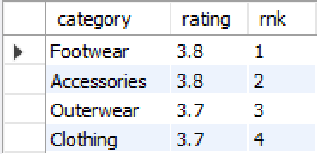

- Subscription vs Non-Subscription Spending – Compared average spend between subscriber and non-subscriber groups.
SELECT subscription_status, count(customer_id) AS Total_customers,
round(avg(purchase_amount),2) AS avg_spend,
round(sum(purchase_amount),2) AS total_revenue
FROM customer
GROUP BY subscription_status
ORDER BY total_revenue, avg_spend DESC;
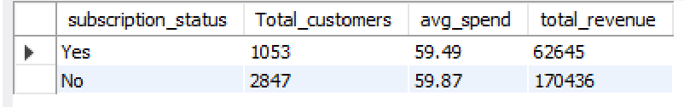

- Seasonal Trends – Analyzed purchase patterns across seasons.
SELECT season, category, sum(purchase_amount) AS avg_spend
FROM customer
GROUP BY category, season
ORDER BY avg_spend DESC;
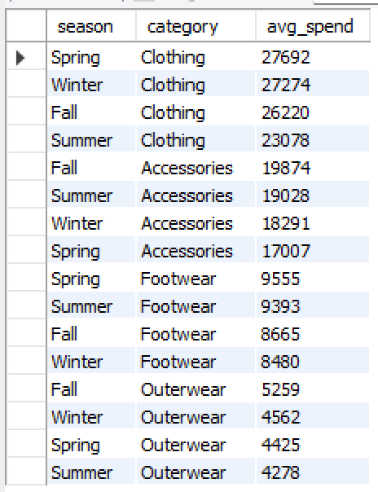
- Shipping Preference Analysis – Examined which shipping types drive higher revenue.
SELECT shipping_type, avg(purchase_amount) AS avg_spend
FROM customer
GROUP BY shipping_type
ORDER BY avg_spend DESC;
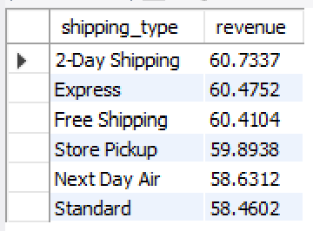
- Customer Segmentation – Classified customers into segments (New, Returning, Loyal) based on purchase frequency.
WITH customer_type AS (
SELECT customer_id, previous_purchases, purchase_amount,
CASE
WHEN previous_purchases = 1 THEN 'New'
WHEN previous_purchases BETWEEN 2 AND 10 THEN 'Returning'
ELSE 'Loyal'
END AS customer_segment
FROM customer
)
SELECT
customer_segment,
COUNT(*) AS "Number of Customers",
avg(purchase_amount) AS avg_spend
FROM customer_type
GROUP BY customer_segment;
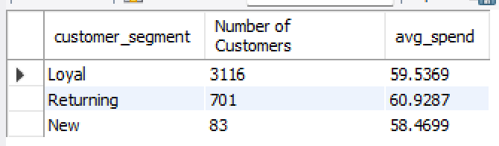

- Discount Impact – Measured how discounts affect average purchase amounts.
SELECT discount_applied, avg(purchase_amount) AS avg_purchase_amount
FROM customer
GROUP BY discount_applied;
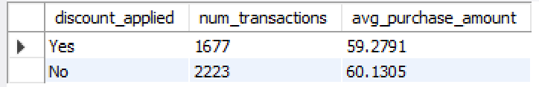

6. Key Findings
- Age Group Revenue: Certain age group (mid) generate disproportionately higher revenue ($110945), indicating prime target demographics for marketing.
- Seasonal Patterns: Purchase behavior varies across seasons, with specific categories peaking in different seasons. Clothing in spring generating $27692, accessories in fall $19847, footwear in spring $9555, outerwear in fall $5259.
- Discount Effect: Discounts influence purchase amounts, requiring careful balance between volume growth and margin control.
- Customer Segments: The majority of customers fall in the ‘Loyal’ segment, total no. of customers 3116 with avg_spend of $59.5
- Shipping Preference: 2-Day Shipping users tend to have higher average order values.

7. Dashboard using Power Bi

Dashboard KPIs
• Total Customers: 3.9K
• Average Purchase Amount: $59.76
• Average Review Rating: 3.75
• Subscription Status Distribution: 73% Non-Subscribers, 27% Subscribers
• Clothing generated the highest revenue and sales volume.
• Mid-age customers contributed the highest revenue and sales volume.
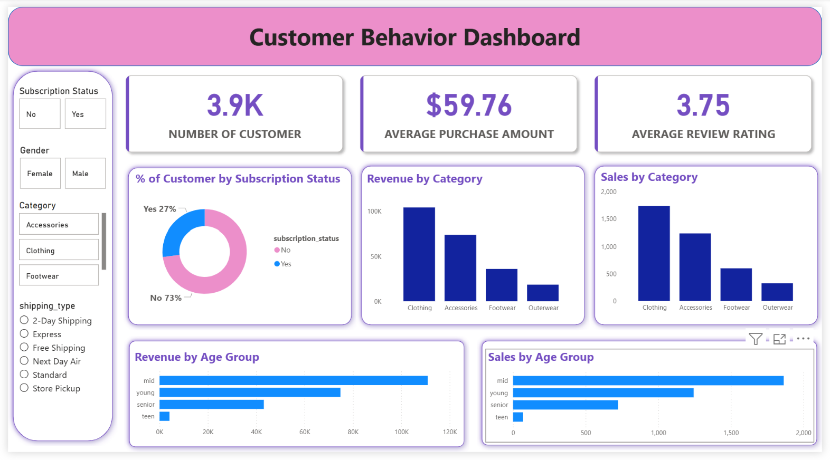

8. Business Recommendations
Based on the synthesized findings, the following actions are recommended to optimize market position:
- Boost Subscriptions Growth: Design and promote exclusive, high-value benefits for to increase the subscriber base and drive higher per-customer revenue.
- Refine Loyalty Frameworks: Reward repeat buyers to move them into the 'Loyal' segment.
- Review Discount Policy – Balance sales boosts with margin control by targeting discounts strategically.
- Optimize Product Positioning: Aggressively highlight top-rated items and best-sellers (specifically within the "Clothing" category) in digital storefronts to leverage social proof.
- Execute Targeted Marketing: Focus advertising spend on the top-performing age_group cohorts and prioritize retention efforts toward users who frequently select express shipping, as they represent a high-value.

